Name: **Satish Kumar Sharma**

BITS ID: **2022MT93327**

Course Name: **Edge Computing**

Course Id: **SEZG586**

**Q: The complexity of these Edge computing systems has given rise to a number of technical challenges, such as mobility management, security and privacy, scalability, heterogeneity, reliability, and resource management. From the above list which 3 attributes are more complex compare to others and why?**

**Ans:**

As an Edge Computing, I am analyzing the technical challenges mentioned and identify the three attributes that are often considered more complex compared to others:

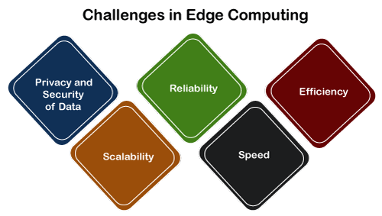

1. **Security and Privacy:**

* **Complexity:** Security and privacy issues are important in negotiations due to the impact of the process. Edge devices are often used in multiple locations and are potentially insecure, making security measures difficult to implement. Additionally, processing sensitive data at the edge requires strong encryption, authentication, and access control mechanisms.

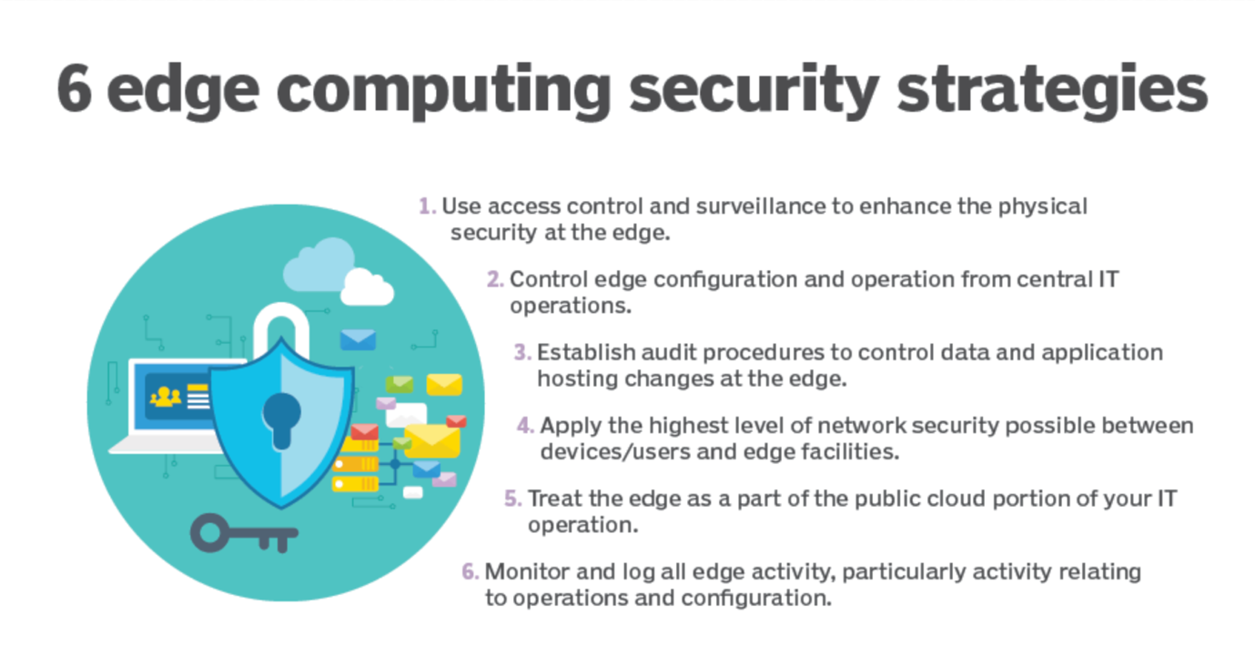

* **Reasoning:** The closer the end equipment is to the data, which increases the risk of physical access and makes security measures important. Additionally, when processing local data, privacy issues arise that require careful handling of personally identifiable information (PII) and compliance with data protection laws.

1. **Scalability:**

**• Complexity**: Scalability in edge computing by managing a dynamic and heterogeneous network of devices, each capable of doing different things. Unlike the cloud, where resources can be easily added or removed, the edge environment needs flexibility to handle changing tasks effectively.

**• Reasoning:** Edge recording will meet different needs depending on the user's location, time of day and environment. Environmental conditions. Scaling edge systems while maintaining low latency and high performance creates challenges in balancing equipment, resource allocation, and coordination between nodes.

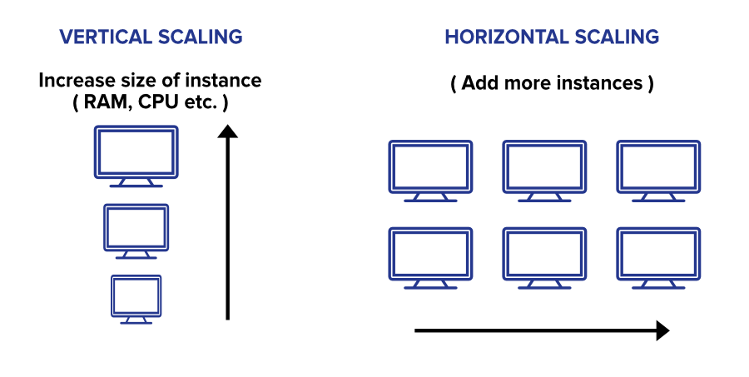

1. **Mobility Management:**

**• Complexity:** Edge devices (especially in mobile and IoT scenarios) can be very mobile, causing problems in managing connections between different end nodes and causing seamless migration issues. . Ensuring service continuity as devices move across the network is a difficult task.

**• Reasoning:** Mobile Edge Computing (MEC) and IoT devices typically operate in a mobile environment; therefore, issues such as usage, resource allocation, and ongoing management need to be addressed. Effective network management is crucial for applications that require uninterrupted connectivity and low-latency services.

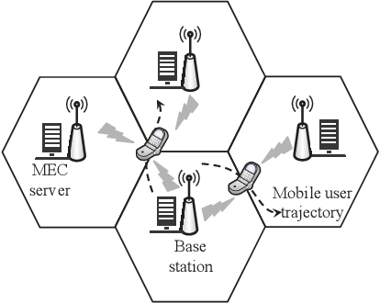

1. **Reliability:**

* **Complexity Explanation:** Edge computing systems often involve numerous edge devices and servers distributed across different locations. Ensuring reliable operation under varying conditions, such as intermittent connectivity and dynamic workloads, is complex. Edge devices may face environmental challenges, and the system needs to be resilient to device failures or network disruptions.
* **Why it's More Complex:** Achieving high reliability in edge computing demands comprehensive fault tolerance mechanisms, dynamic load balancing, and adaptive resource allocation. Handling the diverse nature of edge devices and mitigating the impact of device failures on the overall system requires sophisticated strategies.

Although all features address issues, these three (security and privacy, scalability, and performance management) are the most common. This is particularly difficult because they affect the cutting edge of technology. . Solving these problems effectively requires a combination of advanced technology, design thinking, and adherence to best practices in edge and cloud computing.

**2: Multi-Access Edge Computing (MEC) is useful for real-time applications. What factors signifies this? What are several ways in which MEC enhances the performance of real-time applications?**

**Ans:**

As an Edge Computing Engineer, I understand that Multi-Access Edge Computing (MEC) plays a crucial role in enhancing the performance of real-time applications. Here are several factors and ways in which MEC contributes to the effectiveness of real-time applications:

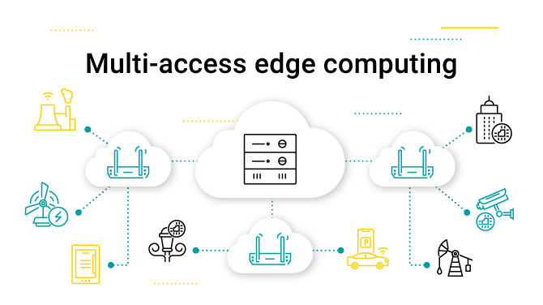

**Factors Signifying MEC's Importance for Real-Time Applications:**

**1. Proximity to the end user:**

* MEC delivers computing devices at the edge of the network, close to end users and IoT devices. This closeness reduces latency and supports immediate interaction and responsiveness.

**2. Low latency communication:**

* MEC allows low speed communication between devices and applications. This is important for applications where latency needs to be minimized, such as augmented reality, virtual reality and industrial automation.

**3. High bandwidth and throughput:**

* MEC leverages edge infrastructure to deliver high bandwidth and throughput. This is useful for applications such as video streaming, radio broadcasting, and high-tech work that requires the rapid exchange of large amounts of data.

**4. Removing resources:**

* Realtime applications often require a lot of computational data. MEC allows the transfer of computing from edge devices to edge servers, eliminating unnecessary hardware and increasing efficiency.

**5. Content information:**

* MEC can include context awareness, where edge servers analyze data in real time based on the context of the application or user. This allows for instant personalized and customized responses.

**How MEC increases efficiency:**

**1. Edge data processing:**

* MEC performs data processing at the edge, reducing the need to send data to central cloud servers. This reduces processing time and facilitates quick decision-making.

**2. Caching and Content Delivery:**

* MEC supports edge caching and content delivery, reducing the latency associated with providing data from remote servers. This is especially useful for applications that require frequent data entry.

**3. Local Analysis and Inference:**

* MEC facilitates local analysis and inference of machine learning models. Real-time applications such as product authentication or error detection benefit from the ability to perform edge computing.

**4. Quality of Service (QoS) Operations:**

* MEC allows Quality of Service policies to be managed at the edge to ensure applications use time to meet requirements. This includes latency, reliability and availability guarantees.

**5. Dynamic resource allocation:**

* MEC platform supports resource allocation based on real-time needs. This change ensures that resources are allocated efficiently and scaled up or down as needed to maintain the application's performance.

**6. Network slicing:**

* MEC supports network slicing, allowing discrete, real-time network slicing to be created for specific applications. This ensures that specific resources and connections are kept as low as each application needs.

MEC significantly improves the performance of real-time applications by leveraging key features and capabilities, making it an important technology for low-latency scenarios. Latency, high performance and efficient use of resources are important.

**Thank You**